PHW250B Journal Club Assignment 2 - ANSWERS
Measures of association and cohort studies

Questions about Manson et al., 2003

Problem 1. Describe the cumulative hazard rate of CHD in the treatment and placebo groups as years of follow-up increased. (2-3 sentences)

The cumulative hazard of CHD was higher in the treatment group than in the placebo group from shortly after the beginning of follow-up until a little after 6 and a half years of follow-up, when the hazard rate was equal. For most of the follow-up period, the difference in the hazard rate between the two groups was approximately 0.0025 to 0.005.

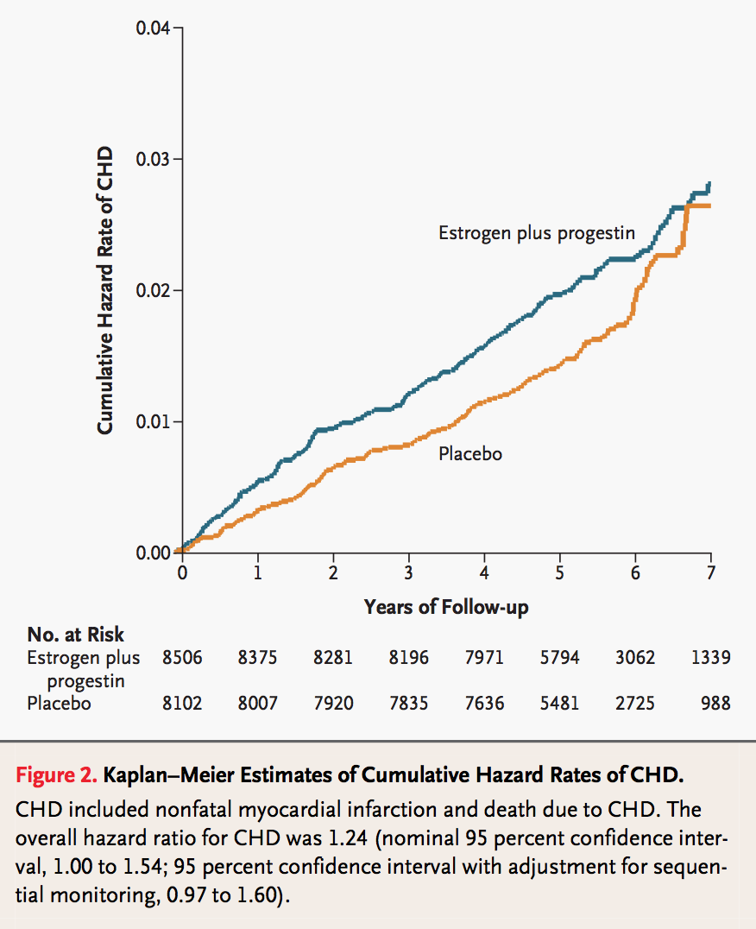

Problem 2. Provide one reason, specific to this study design, that the hazard rates may have become closer between the two groups as the follow-up time increased? Explain your answer (2-4 sentences).

Selection bias: women in the treatment group were more likely to have CHD events and would be excluded from the population at risk after their CHD event. As a result, as the follow-up time increased, the population would include fewer and fewer women for whom the treatment was likely to cause CHD. This can ultimately lead to an apparent protective effect of treatment if one calculates the HR for a later period of the follow-up.

Problem 3. Interpret the hazard ratio reported in the caption of Figure 2, and include an interpretation of the “nominal” 95% CI.

HR = 1.24 (95% CI 1.00, 1.54)
The hazard of coronary heart disease was 1.24-fold higher among women in the estrogen + progestin treatment group compared to the placebo group. There was 95% confidence that the interval 1.00 to 1.54 contains the true hazard ratio. Since this confidence interval includes the null (HR=1), we cannot statistically distinguish this result from a null finding.

Questions about Arnold et al., 2017

Problem 4. Describe why a prospective cohort study was appropriate for this research question. (2-4 sentences)

Since the population of interest was surfers, a prospective cohort study was appropriate because there was no prior data available on surfing activity, weather, and health outcomes, so it was necessary to collect primary data on surfers, including their surfing activity and health outcomes. Collecting prospective data also allowed for the analysis to account for the induction period between surfing and disease and to do a careful analysis that ensured the period of person-time classified as exposed preceded the time of the outcome.

In San Diego, where the study was conducted, the weather is dry even in the winter, so using a cohort design allowed investigators to collect information on surfers over two years to ensure there was sufficient data to test the hypotheses of the study.

It would not have been feasible to randomize surfers to surf after different weather events in order to conduct a randomized trial. The type of surfers who would agree to participate in such a study are likely to be systematically different from those who would not want to participate, which could reduce the generalizability of the results and potentially introduce selection bias.

Problem 5. Would a case-control study have been appropriate for this research question? Explain your answer (2-4 sentences).

In order to conduct a case-control study, the investigators would have to identify cases of infectious illness among surfers who surfed after rainstorms and during dry weather. This would be incredibly difficult to do because there is no roster of surfers, so case identification would have been extremely difficult. Instead, it made sense to enroll people who do surf in different weather conditions and then to follow them over time to measure outcomes under different weather conditions.

Problem 6. Would a cross-sectional study have been appropriate for this research question? Explain your answer (2-4 sentences)

A cross-sectional study could have been done among surfers by surveying surfers and ascertaining exposure and outcome information at the same time. A major disadvantage of a cross-sectional design for this question is that it would be difficult to be confident about the time ordering of the exposure and outcome. If the outcome preceded the exposure, the results would not be valid. In addition, with a cross-sectional design it would be difficult to ensure that there were enough people who had surfed after rain storms since investigators would only measure each surfer one time. As mentioned above in San Diego, the weather is dry even in the winter, so using a cohort design allowed investigators to collect information on surfers over two years to ensure there was sufficient data to test the hypotheses of the study.

Problem 7. Did this study enroll an open or closed population? Justify your answer. (1-2 sentences)

The study enrolled an open population. Surfers could have entered or exited the study population throughout the course of the study. This allowed investigators to capture multiple surfing and non-surfing exposure periods for each individual who enrolled in the study.

Problem 8. For the research question in this study, describe each of the following stages of disease progression: (1 sentence each)
- Causal action
- Disease initiation
- Clinical symptoms
- Recovery

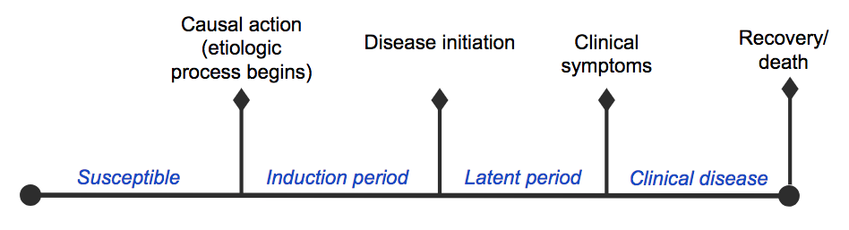

Answer:
- Causal action: surfing in coastal water
- Disease initiation: gastrointestinal, respiratory, or other infectious disease initiates but symptoms are not detectable yet
- Clinical symptoms: gastrointestinal, respiratory, or other infectious disease symptoms are detectable
- Recovery: surfer recovers from gastrointestinal, respiratory, or other infectious disease (specifically for at least 6 days in the study)

Problem 9.
- On page 4, the authors state: “We defined incident episodes as the onset of symptoms preceded by 6 or more symptom-free days to increase the likelihood that separate episodes represented distinct infections (17, 18).” Which period(s) in the figure below does the 6 days mentioned in this quote refer to? (choose all that apply):
- Susceptible
- Induction period
- Latent period
- Clinical disease
The 6 day period without symptoms prior to incident onset of illness symptoms is intended to capture the induction and latent periods between when the disease onset process initiated (after surfing) and prior to the beginning of clinical symptoms. Technically this could include the susceptible period as well, but later in the article the authors discuss how the exposure period following surfing was defined as 3 days. Thus, in order for a disease onset to be classified as within an exposed period, it would need to occur within 3 days of surfing. From this we can conclude that it is unlikely that the authors intended for the susceptible period to be part of the 6 day window.

- Justify the answer(s) you chose in a. (2-3 sentences)

The correct answer is the induction and latent periods. For frequent surfers, it may be difficult to attribute disease events to specific surfing events. Using a 6 day symptom-free window to separate incident episodes of illness implies that the time between the causal action (surfing) and the initiation of symptoms is approximately 6 days.

Problem 10. Describe how the following exposure categories were defined in the study (2-3 sentences each):
a) exposed vs. unexposed
b) exposed to wet weather

On page 4:

a) “We classified the 3 days after each seawater exposure as exposed periods and all other days of observation as unexposed periods.”

b) “We defined wet-weather exposure as exposure to seawater within 3 days of 0.25 cm or more of rainfall in a 24-hour period, which is the rainfall criterion used by San Diego County for posting wet-weather beach advisories; we classified all other seawater exposure as dry-weather exposure.”

Problem 11. Provide an example of how loss to follow-up could have occurred in this study. (1 sentence)

Surfers could have been enrolled on the beach but never signed into the study app.
Surfers could have reported surfing activity and illness symptoms for a few weeks and then stopped after that.
Surfers could have moved out of the study area and declined to continue to enter data into the app.

Problem 12. Using data from Table 2, calculate the incidence rate ratio (IRR) for gastrointestinal illness a) comparing wet-weather exposure to dry-weather exposure, b) comparing wet-weather exposure to unexposed periods, and c) dry-weather exposure to unexposed. Which IRR is associated with the greatest increase in the rate of gastrointestinal illness?

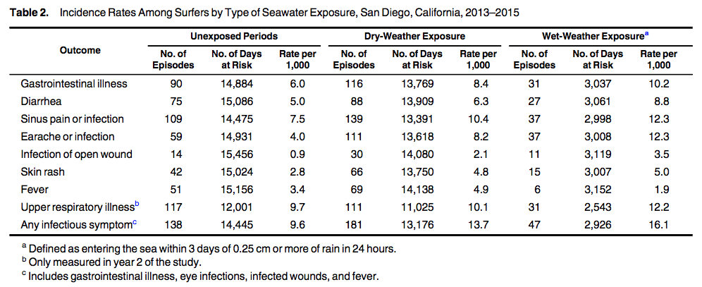

a) Wet-weather exposure to dry-weather exposure: 10.2/8.4 = 1.2
b) Wet-weather exposure to unexposed periods: 10.2/6.0 = 1.7
c) Dry-weather exposure to unexposed: 8.4/6.0 = 1.4

The IRR for wet-weather exposure to unexposed periods was associated with the greatest fold increase in rate of gastrointestinal illness.

Problem 13. In the study, what was the unexposed group used in IRRs for wet-weather exposure? What was the unexposed group used in IRRs for dry-weather exposure? (1-3 sentences)

The investigators “created a 3- level categorical exposure that classified each participant’s follow-up time into unexposed, dry-weather exposure, and wet-weather exposure periods.” (Page 4). The unexposed group for both types of IRR was “unexposed” periods defined as periods with no seawater exposure.

Problem 14. Interpret the unadjusted IRRs for gastrointestinal illness from Table 3 for wet and dry weather. How do the IRRs compare? What do you conclude? (3-5 sentences)
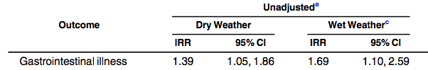

Sea water exposure from surfing after wet weather was associated with a 1.69-fold increase (95% 1.10, 2.59) in the rate of gastrointestinal illness compared to times when surfers did not enter the water. Exposure during dry weather was associated with a 1.39-fold increase in gastrointestinal illness. These findings suggest that seawater exposure after wet weather is associated with more gastrointestinal illness than exposure during dry weather (though the confidence intervals overlap, so these two IRR estimates cannot be distinguished from each other). [Since these are unadjusted IRRs, they may be subject to confounding]

Problem 15. In the modern causal perspective on measures of association, what would be a limitation of estimating an IRR in this study compared to estimating an incidence rate difference? (3-5 sentences)

The RR depends not only on the people amenable to intervention (“causal” and “preventive” types) but also on the people who are doomed. The RD only depends on people amenable to intervention. If the proportion of the doomed in the population is high, the causal effect is diluted compared to when doomed proportion is lower. In both cases, the RD stays the same. For this reason, some have argued that the RD is a better measure of causal impact than the RR.

Problem 16. Table 2 presents estimates of incidence rates for different health outcomes for exposed and unexposed periods of time. What else is needed to calculate the population attributable fraction associated with dry- or wet-weather exposure for surfers? (1 sentence)

The total incidence rate in the study population, including both exposed and unexposed periods. Or the prevalence of wet-weather exposure versus dry-weather exposure.

Problem 17. Suppose you estimated that the population attributable fraction for ear infection associated with surfing during wet weather was 0.25. Which of the following causal interpretations of this finding is correct (select all that apply)?
- 75% of ear infections among surfers are due to surfing after dry weather.
- 25% of incident ear infections among surfers are due to surfing following wet weather, which means that the majority of ear infections occur among surfers with no known risk factors.
- 25% of incident ear infections among surfers would be eliminated if they did not surf following wet weather. Correct

Problem 18. Why would it not be useful to calculate a PAF for ear infection and having never surfed using data from this study? (2- 4 sentences)

Ideally the unexposed category in a PAF is defined in a way that makes it realistic for the exposed people to become unexposed. This study enrolled surfers, so it’s not useful to imagine a scenario in which these study participants had never surfed. It’s more useful to focus on modifiable exposures, like surfing after wet weather.

